Q1
(a)(1)
Jayden
(2)
1
(3)
Begin with the complete dictionary as a current partition and find the entry in the middle of the partition
As the entry is JAYDEN return the information indexed at that location in the list.
(b)(1)
Aaron
(2)
6
(3) begin with the complete dictionary as a current partition
find the entry in the middle of the partition and name this the current entry
it is not AARON so divide the current partition into two segments either side of the current entry.
(first iteration complete)
AARON is in the first segment so this segment becomes the new partition
find the entry in the middle of the partition and name this the current entry
it is not AARON so divide the current partition into two segments either side of the current entry.
(second iteration complete)
find the entry in the middle of the partition and name this the current entry
it is not AARON so divide the current partition into two segments either side of the current entry.
(third iteration complete)
find the entry in the middle of the partition and name this the current entry
it is not AARON so divide the current partition into two segments either side of the current entry.
(fourth iteration complete)
find the entry in the middle of the partition and name this the current entry
it is not AARON so divide the current partition into two segments either side of the current entry.
(fifth iteration complete)
find the entry in the middle of the partition and name this the current entry
as the entry is AARON return the information indexed at that location in the list.
(sixth iteration complete)

(c)
By having the names listed in alphabetical order the algorithm can depend on the precedence of the data list to be linear in such a manner that the list can be partitioned sequentially until the result is found
(d)

Q2

Dear Joe, Thank you for your enthusiastic submission. You have selected a good current example of a computer system which can highlight the validity of Alan Turnings Hypothesis on Intelligence.I am pleased to inform you, you have passed as you have tackled the heart of the subject well, but there are problems with structure, grammar which lowered your score that we need to address for future works.

Joe, the point on Watsons limits to general use are well defined. However bear in mind that there is not a general agreement on the validity of the Turing test as a key indicator of intelligence in computer science. i.e. Even if Watson could handle follow up questions, or more generality would it possess human level generality or even efficiency ? As Dave Ferruci of IBM points out in his interviews, A human can still compute far more in a small size with magnitudes less power. However you are also correct in that Ferruci agrees Watson does not yet have general learning capability. Perhaps what can compute more “generally” is maybe a more interesting definition for intelligence than Turing’s concept of imitation ? It can be argued that the ability to predict and imitate required input, output processes is one maker of intelligence, but again this would need to be a generalized imitation capability.

Advise the student on how to avoid future errors by looking forward and improving their skills. Refer them to any appropriate study/skills resources on the M269 website.

Overall the question was well tackled and the mark could have been far higher. It was lowered primarily on the structure and grammar pointed out. The spell checker of the word processor can find many of the spelling mistakes. In regard to grammar points particularly terms of reference try and imagine if you were reading somebody else work, could you follow it so clearly ? In terms of paragraph structure, try and think about how you are telling a story. Introduction, the story, and the conclusion. Introduction and conclusion should be one paragraph. If it is longer, try and shorten.

Your feedback should not be longer than 400 words. Focus on the main strengths and weaknesses and how future work could be improved.
Do not include in your feedback information on the specific number of marks gained or lost for parts of the assignment. Through assessment, we want to instil the mindset in our students not of ‘What was my mark? … now carry on’, but of‘What have I learnt and how can I apply it in the future?’

Q3

(a)
The output is specified as a real number because the calculation for the postcondition d is a square root. Square roots produce values in the real number domain. i.e. for the points (2, 2) and (4, 5) d=SQR ((2-4)² + (2-5)²) = 3.601 to 3 s.p.
(b)

import math
def calculateDistance(loc1, loc2):
d=math.sqrt((loc1[0]-loc2[0])**2 + (loc1[1]-loc2[1])**2)
return d

testDistance = calculateDistance((1,2), (5,3))
print(testDistance)
(c)

newgrid=Grid(4)
newgrid.setValue(1,1,1)
newgrid.setValue(2,2,2)
newgrid.setValue(3,3,3)
newgrid.setValue(4,4,4)
print(newgrid)

(d)

Class Grid ADT listOfRows first problem was for a “list” of rows where “list” and “rows” scale in proportion to each other with respect to the grid size n. The programmer had to think of generating a data structure with one loop iterating over another with the same value. i.e.
The loop defined by i gives n rows with single integer values so iterates n times
The loop defined by j fills the nth row with ‘*’ and also appends its own list of rows with another row n times, so the number of integer values generated with ‘*’ is n times n.
To place values in the ADT the method setValue places value into the listOfRows by finding the row with x(-1) then within that row the location y(-1)
This because the listOfRows is already structured as follows (if for example n is 2)
Row [0] = [*,*]
Row [1] = [*,*]
(__str__) is a regular python method by which data is converted to strings within the print function. So the method (__str__) is required when a new class (listOfRow in this case) is being setup to respond to the print function.
(e)
First of all define the grid length by the size of the list
In this grid we generate each part of the grid distance calculation occurs against each other part.
We use the existing functions for grid generation, distance calculation, placing calculations into the grid, and printing of the final grid
In the following manner
Generate a loop to work through each grid row,
Use a row counter to control and end this loop.
Generate a nested loop to work through each column
Use a row counter to control and end this loop.
the first row location is distance calculated against the first column then placed into the grid.
then the next column against that row until the end of the row is reached, and the same process will occur for each row by means of the outside loop moving to the next row until the grid is exhausted
We call the function with the List data which is returned and we can print it.
(f)
def makeDistancesGrid(locList):
n = len(locList)
locgrid = Grid(n)
row = 0
while row < n:
col = 0
while col < n:
distance = calculateDistance (locList[row],locList[col])
locgrid.setValue(row, col, distance)
col = col + 1
row = row + 1
# end while
# end while
return locgrid

locList = [(1,1), (2,3), (33,5), (11,55), (99,1), (50,40)]
solutiongrid = makeDistancesGrid(locList)
print (solutiongrid)

(g)
[[0.0, 31.064449134018133, 52.773099207835045, 97.02061636580135, 60.60528029800704, 2.23606797749979], [31.064449134018133, 0.0, 54.62600113499065, 66.12110101926616, 38.91015291668744, 32.2490309931942], [52.773099207835045, 54.62600113499065, 0.0, 103.24727599312246, 41.78516483155236, 54.91812087098393], [97.02061636580135, 66.12110101926616, 103.24727599312246, 0.0, 62.625873247404705, 98.0], [60.60528029800704, 38.91015291668744, 41.78516483155236, 62.625873247404705, 0.0, 62.625873247404705], [2.23606797749979, 32.2490309931942, 54.91812087098393, 98.0, 62.625873247404705, 0.0]]

Q4

(a) (1)
Operation: enqueue(item)
Preconditions: ¬isFull()
Postconditions:
The first element will have been added
The size of the stack will have been increased by 1

Operation: dequeue(item)
Preconditions: ¬isEmpty()
Postconditions:
The end element will have been removed and returned
The size of the stack will have been decreased by 1

(2)

Operation: size
Inputs: A sequence of integers I = (i₁, i₂, i₃, …, i_{n})
Outputs: An integer h ?
Preconditions: Length of I > 0
Postconditions: h is in I and h ≥ i_{k} for all i_{k} in I

(3)
size() ≤ maxSize()

(4)
Operation: truncate(i)
Inputs: integer i
Outputs: True or Flase
Preconditions: i > 0 < maxsize
Postconditions: last i items are removed from the queue

(b) (1)
def truncate (aQueue, lastX):
assert aQueue.size() > 0 < lastX
while lastX > 0:
aQueue.dequeue()
lastX = lastX - 1
return aQueue
#end while

(2)
def truncate (self, lastX):
assert self.size() > 0 < lastX
while lastX > 0:
self.dequeue()
lastX = lastX - 1
return self
#print (aQueue.items)
#end while

Q5

(a)
S=(2, 7, 1, 8, 2, 8, 4, 5, 10, 0, 4, 5)

best=0

for i in range(len(S)):
stepi = S[i]
newrange = len(S) - 1
for j in range (newrange):
currentcalc = S[i]- S[j]
if currentcalc > best :
best=currentcalc
if currentcalc < best :
buy=currentcalc
# end for
#end for

transaction = best - buy
print(transaction)

(b)
There are 12 outer loops for i and 11 inner loops for j
There are n outer loops with 2 steps
There are n-1 inner loops with 3 steps
There are 4 out of loop steps
So (2n x 3n) + 4 with 12 values for n = 868 steps
(c)
For run time complexity we approximate any polynomials (or selection of them) to the value in it which first n has the highest power of n. Then from there (if choosing between polynomials) we select the polynomial with highest operand. After this selection we can estimate Complexity by rounding of n to its power. i.e. for this example
(2n x 3n) + 4 = 6n² +4
No selection between other polynomials so proceed to round this to O(n²)
(d)(1)

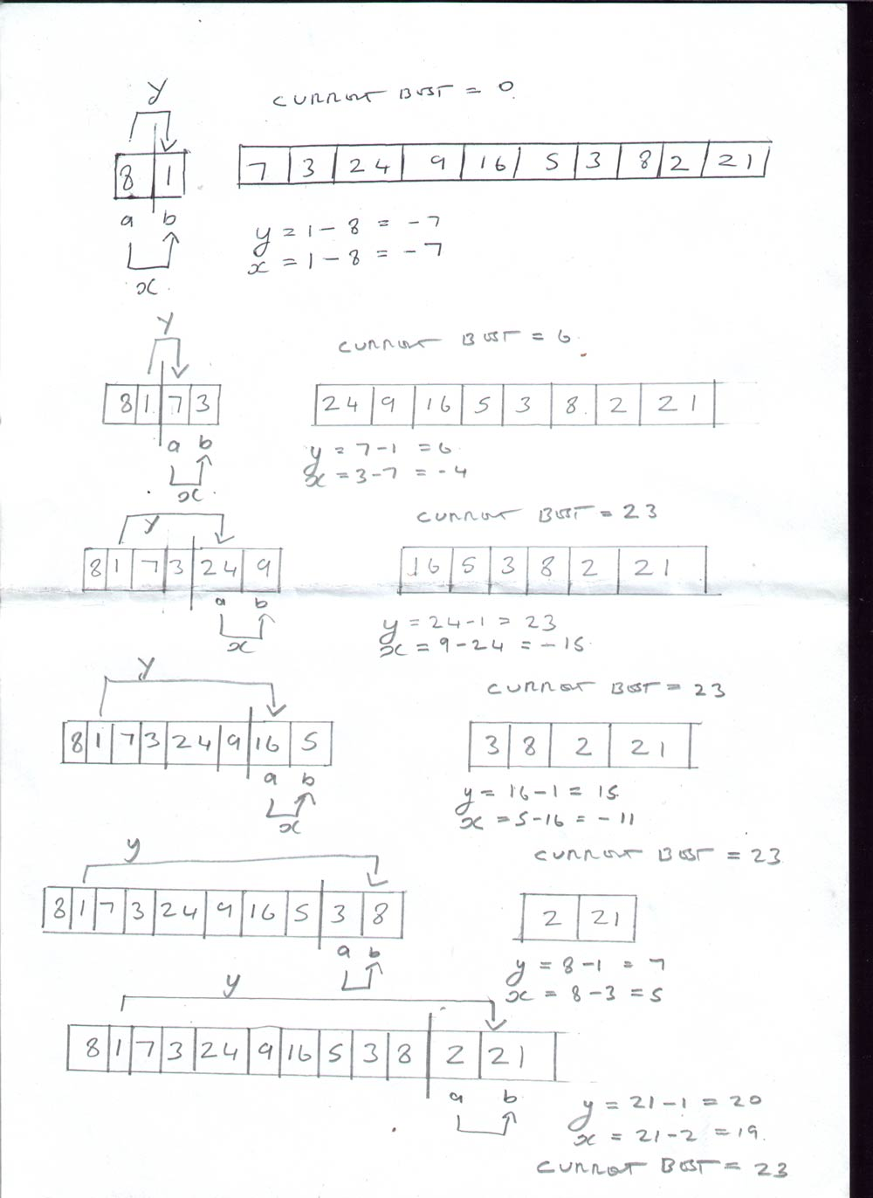

(2)
6n² +4
n=12 so n = 868 steps
(3)
Breaking down the steps…
  - set the best profit to 0 (1 step out of main loop)
  - take the first two items, a and b in the sequence (1 step out of main loop)
  - set the end of the current partition to the second item in the sequence divide the current partition into two equal halves (2 steps out of main loop)
  - LOOP START subtract the smallest item in the left half from the largest item in the right half, giving result y (1 step)
  - subtract a from b giving result x (1 step)
  - set the new best profit to be the greater of x and y, or the current best profit (1 step)
  - set a and b to the next two items in the sequence (1 step)
  - make b the end of the current partition (1 step)
  - LOOP RETURN IF if not at the end of the list, go back to step 4 (1 step)
  - return the best profit. (1 step out of main loop)

There are 4 steps before the main loop
There are 6 steps within the main loop which loops n/2 times
There is one step after the main loop

So steps = 6n/2 + 5
For n=12 steps are 41

